**Product Recommendation System**



**Session: BSSE Fall 2021 to 2025**

**Project Advisor: Ms. Hadiqa**

**Submitted By**

|  |  |
| --- | --- |
| Muhammad Sohaib Raza | BSE21033 |
|  |  |

Department of Computer Science & IT

University of the Punjab, Gujranwala Campu

## *Abstract*

The Product Recommendation System (PRS) is an AI-powered solution designed to enhance user experience in e-commerce by providing personalized product suggestions. With the increasing number of products available online, users face decision fatigue, making it difficult to find relevant items. PRS aims to solve this issue by recommending products based on user behavior, browsing history, purchase records, and preferences.

**Problem Statement**

Traditional recommendation systems face challenges such as over-personalization, lack of contextual awareness, poor accuracy, and scalability issues.

**Procedures**

To overcome these limitations, PRS integrates:

* Machine Learning algorithms (collaborative filtering, content-based filtering, and hybrid approaches).
* Context-aware recommendations, considering factors like time, location, and shopping trends.
* User feedback mechanisms to refine recommendations.
* Scalable architecture to handle large datasets efficiently.

**Results**

PRS provides more relevant, diverse, and accurate product recommendations, increasing user engagement and sales. The system effectively reduces search time, prevents filter bubbles, and improves business insights. Performance tests indicate faster recommendation generation and higher accuracy compared to conventional methods.

**Conclusions**

The PRS successfully addresses the shortcomings of traditional recommendation systems by combining AI-driven personalization, contextual awareness, and scalable infrastructure. This enhances user experience, optimizes sales for businesses, and ensures adaptability across various e-commerce platforms.

***Area of the Project***

The **Product Recommendation System (PRS)** falls under the following areas:

**Machine Learning** – Uses algorithms like collaborative filtering, content-based filtering, and hybrid approaches for recommendations.

**Artificial Intelligence** – Implements AI techniques for intelligent product suggestions and context-aware recommendations.

**Web Application** – Designed as a web-based solution to integrate with e-commerce platforms.

***Technologies used***

**Programming Languages**

* **Python** – For developing recommendation algorithms.
* **JavaScript** – For front-end functionality.
* **PHP** – For backend development.

**Frontend Technologies**

* **HTML, CSS, JavaScript** – To design and build the user interface.

**Backend & Databases**

* **MySQL** – For structured data storage.
* **MongoDB** – For handling unstructured or semi-structured data.

**Machine Learning & AI Libraries**

* **TensorFlow** – For implementing deep learning models.
* **Scikit-learn** – For traditional machine learning algorithms.

**API & Security**

* **RESTful APIs** – For communication between frontend, backend, and recommendation models.
* **SSL/TLS encryption** – To ensure secure data transmission.

**Deployment & Scalability**

* **Cloud-based hosting (AWS, Google Cloud, or Azure)** – For handling large datasets and real-time recommendations.

This AI-powered web-based system ensures scalability, accuracy, and security while providing personalized product recommendations.

# List of Figures

Figure 1: Block Diagram of PRS 6

Figure 2: Use Case Diagram for User Registration and Login 20

Figure 3: Use Case Diagram Generating Product Recommendation 21

Figure 4: Use Case Diagram View Product Details 22

Figure 5: Use Case Diagram Providing Feedback 23

Figure 6: Use Case Diagram for Search Products 24

Figure 7: Use Case Diagram View Purchase History 25

Figure 8: Aggregated Use Case Diagram of PRS 27

Figure 9 Architecture Diagram of PRS 28

Figure 10 ERD of PRS 29

Figure 11 Class Diagram 30

Figure 12: User Registration and Login 31

Figure 13: Generating Product Recommendations 31

Figure 14: View Product Details Activity 32

Figure 15: Provide Feedback on Recommendation 32

Figure 16: Search for Products Activity 33

Figure 17: View Purchase History 33

Figure 18: Activity Diagram of PRS 34

Figure 19: Sequence diagram for User Registration and login 35

Figure 20: Sequence diagram for Generating Product Recommendations 36

Figure 21: Sequence diagram for View Product Details 36

Figure 22: Sequence diagram for Provide Feedback on Recommendations 37

Figure 23: Sequence diagram for Search for products 37

Figure 24: Sequence diagram for View Purchase history 38

Figure 25: Sequence Diagram of PRS 38

Figure 26 Collaboration Diagram of PRS 39

Figure 27: DFD of PRS 40

Figure 28: Component Diagram of PRS 41

Figure 29: ST diagram of PRS 41

Figure 30: Deployment Diagram od PRS 42

## List of Tables

Table 1 Functional Requirement Generate Product Recommendations 7

Table 2: Functional Requirement View Product Details 8

Table 3: Functional Requirement Provide Feedback on Recommendations 8

Table 4: Functional Requirement Manage User Profile 9

Table 5: Functional Requirement Login & Logout 9

Table 6: Functional Requirement Search for Products 10

Table 7: Functional Requirement View Purchase History 10

Table 8 Use Case User Registration and login 21

Table 9: Use Case Generating Product Recommendation 22

Table 10: Use Case Viewing Product Detail 23

Table 11: Provide Feedback on Recommendation 24

Table 12: Searching for Products 25

Table 13: Viewing Purchase History Use Case 26

**Table of Content**

*Abstract* i

List of Figures iii

List of Tables iv

Chapter 1: Introduction to the Problem 1

1.1 Introduction 1

1.2 Purpose 1

1.3 Objective 1

1.4 Existing Solution 1

1.5 Proposed Solution 2

Chapter 2: Software Requirement Specification 3

2.1 Introduction 3

2.1.1 Purpose 3

2.1.2 Scope 3

2.1.3 Definitions, acronyms, and abbreviations 4

2.2 Overall description 5

2.2.1 Product perspective 5

2.2.2 Product functions 6

2.2.3 User characteristics 10

2.2.4 Constraints 12

2.2.5 Assumptions and dependencies 14

2.2.6 Apportioning of requirements 15

2.3 Specific requirements 16

2.3.1 Functional Requirement 16

2.3.2 Non-functional Requirements 17

Chapter 3: Use Case Analysis 20

3.1. Use Case Diagram for User Registration and Login 20

3.1.1 User Registration and Login 21

3.2. Use Case Diagram for Generating Product Recommendations 21

3.2.1 Generate Product Recommendations 22

3.3 Use Case Diagram for Viewing Product Details 22

3.3.1 Viewing Product Details 23

3.4. Use Case Diagram for Providing Feedback on Recommendations 23

3.4.1 Providing Feedback on Recommendations 24

3.5. Use Case Diagram for Searching for Products 24

3.5.1. Searching for Products 25

3.6. Use Case Diagram for Viewing Purchase History 25

3.6.1. Viewing Purchase History 26

3.7. Aggregated Use Case Diagram 27

Chapter 4: Design 28

4.1 Architecture Diagram 28

4.2 ERD with data dictionary 29

4.3 Class Diagram 29

4.4 Activity Diagram 30

4.4.1 User Registration and Login 31

4.4.2 Generating Product Recommendations 31

4.4.3 Viewing Product Details 32

4.4.4 Provide Feedback on Rcommendations 32

4.4.5 Search for Products 33

4.4.6 View Purchase History 33

4.4.7 Aggregated Activity Diagram of PRS 34

4.5 Sequence Diagram 35

4.5.1 User Registration and Login 35

4.5.2 Generating Product Recommendations 36

4.5.3 Viewing Product Details 36

4.5.4 Providing Feedback on Recommendations 37

4.5.5 Searching for Products 37

4.5.6 Viewing Purchase History 38

4.5.7 Aggregated Diagram 38

4.6 Collaboration Diagram 39

4.7 Data Flow Diagram 40

4.8 Component Diagram 40

4.9 State Transition Diagram 41

4.10 Deployment Diagram 42

References 43

Appendix 44

### Chapter 1: Introduction to the Problem

##### Introduction

The rapid growth of e-commerce has led to an overwhelming number of product choices for users, making it difficult for them to find relevant items. This results in **decision fatigue**, where users struggle to make purchasing decisions, leading to reduced satisfaction and lost sales opportunities for businesses. Traditional browsing methods are no longer effective, as they fail to account for individual user preferences and behaviors.

The **Product Recommendation System** addresses this issue by providing personalized product suggestions based on user data such as browsing history, preferences, and past purchases. By implementing this system, businesses can enhance the user experience, improve customer satisfaction, and increase sales. This project is highly relevant in today’s e-commerce landscape, where personalization is key to staying competitive and meeting the demands of modern consumers.

##### Purpose

The PRS is designed to enhance the user shopping experience by offering personalized product recommendations based on individual preferences, browsing history, and purchasing behavior. This system aims to improve customer satisfaction, increase sales, and support business objectives by delivering relevant product suggestions in real time.

##### Objective

The primary objective of this project is to develop an intelligent **Product Recommendation System** that enhances user experience by suggesting relevant products based on user preferences, browsing behavior, and purchase history. The system aims to:

1. **Improve User Experience** – Provide personalized product recommendations to users, reducing the time and effort required to find suitable products.
2. **Increase Sales and Engagement** – Enhance product visibility and encourage purchases by suggesting relevant products based on user behavior.
3. **Enhance Business Insights** – Provide data-driven insights to businesses, helping them understand customer preferences and market trends.
4. **Ensure Scalability and Efficiency** – Design a system that can handle large datasets and provide real-time recommendations efficiently.

##### Existing Solution

Currently, several **Product Recommendation Systems** are widely used in e-commerce platforms, including Amazon, Netflix, and Spotify. These systems utilize collaborative filtering, content-based filtering, and hybrid approaches to suggest products to users. While they have improved user experience and sales, they still have several limitations:

**i. Over-Personalization**

Some systems overly focus on user preferences, limiting product diversity and reducing the chances of discovering new or less popular items.

**ii. Lack of Context Awareness**

Most recommendation systems fail to consider real-time contextual factors like location, season, or time-based trends while making suggestions.

**iii. Inaccuracy in Recommendations**

Some systems generate irrelevant or generic recommendations due to poor data quality or ineffective algorithms, leading to user dissatisfaction.

**iv. Scalability Issues**

Handling a vast number of users and products in real-time requires significant computational power, making some systems inefficient at a larger scale.

##### Proposed Solution

To overcome the limitations of existing Product Recommendation Systems, we propose an **AI-powered Product Recommendation System** that leverages advanced machine learning techniques, contextual awareness, and enhanced data privacy mechanisms. Our system aims to provide more accurate, diverse, and real-time recommendations while addressing the shortcomings of traditional approaches.

**How Our System Solves Existing Problems**

**1. Cold Start Problem Solution**

We incorporate hybrid filtering (collaborative + content-based) along with metadata analysis to recommend products even for new users or items with limited interaction history.

Implementing demographic-based recommendations for new users before personalized data is collected.

**2. Avoiding Over-Personalization**

Our system ensures recommendation diversity by introducing serendipity and exploration models, preventing users from being stuck in a filter bubble.

**3. Context-Aware Recommendations**

Unlike traditional systems, we integrate contextual data such as time of day, location, season, and user behavior trends to provide more relevant suggestions.

### Chapter 2: Software Requirement Specification

##### Introduction

###### Purpose

The purpose of this Software Requirements Specification (SRS) is to define the functional and non-functional requirements for the Product Recommendation System. It serves as a comprehensive guide for developers, designers, testers, and stakeholders to ensure a clear understanding of the system's objectives, functionalities, and constraints.

This document is intended for:

* **Developers** – To understand the technical requirements and implement the system accordingly.
* **Project Managers** – To oversee the project development and ensure compliance with the defined specifications.
* **Testers** – To validate that the system meets the specified requirements.
* **Business Analysts & Stakeholders** – To ensure the system aligns with business objectives and user expectations.

###### Scope

The software product to be developed is the **Product Recommendation System**.

This system will analyze user preferences, browsing history, and purchasing behavior to provide personalized product recommendations. It will utilize machine learning algorithms to improve recommendation accuracy over time. The system will support multiple product categories and deliver real-time suggestions.

**The system will:**

* Collect and process user interaction data to generate relevant product recommendations.
* Utilize collaborative filtering, content-based filtering, and hybrid approaches for recommendations.
* Provide context-aware suggestions based on real-time factors such as location and time.
* Ensure scalability to handle large datasets efficiently.
* Offer a user-friendly interface for seamless interaction.

**The system will not:**

* Act as a standalone e-commerce platform for purchasing products.
* Store sensitive personal financial information.
* Function without an initial dataset for recommendation generation.

This software will be applied in e-commerce platforms, digital marketplaces, and online retail businesses to enhance user experience, increase engagement, and drive sales. The primary objectives are to improve product discoverability, reduce search time, and provide businesses with data-driven insights to optimize product offerings.

The primary benefits, objectives, and goals include:

* **Enhancing Product Discoverability** – Helping users find relevant products quickly.
* **Reducing Search Time** – Minimizing the effort required for users to explore suitable items.
* **Improving Customer Retention** – Providing personalized experiences to keep users engaged.
* **Boosting Sales & Business Insights** – Enabling businesses to leverage data-driven insights to optimize product offerings and marketing strategies.

###### Definitions, acronyms, and abbreviations

**Definitions**

* **Product Recommendation System** – A software system that suggests relevant products to users based on their preferences, browsing behavior, and purchase history.
* **Recommendation Algorithm** – A set of rules and computations used to generate personalized product suggestions.
* **User Profile** – A collection of user data, including preferences, purchase history, and interactions, used to generate recommendations.
* **Machine Learning (ML)** – A branch of artificial intelligence that enables systems to learn from data and improve recommendations over time.
* **Collaborative Filtering** – A recommendation method that analyzes user behavior and similarities between users to suggest products.
* **Content-Based Filtering** – A recommendation approach that suggests products based on item attributes and user preferences.
* **Hybrid Recommendation System** – A system that combines multiple recommendation approaches, such as collaborative and content-based filtering.

**Acronyms:**

* **SRS** **:** Software Requirements Specification
* **UI :** User Interface
* **UX**: User Experience
* **API:** Application Programming Interface
* **AI:** Artificial Intelligence
* **ML:** Machine Learning
* **DBMS:** Database Management System

**Abbreviations:**

* **RecSys** – Recommendation System
* **Algo** – Algorithm
* **DB** – Database

##### Overall description

###### Product perspective

The **Product Recommendation System** is an independent and self-contained software product designed to enhance the user experience on e-commerce platforms by providing personalized product suggestions. It integrates seamlessly with existing e-commerce systems and operates as a standalone module that can be easily incorporated into various platforms. Below is a detailed breakdown of the product perspective based on the provided guidelines:

**System Interfaces:**

* The system interfaces with the e-commerce platform’s database to fetch user data, product information, and interaction history.
* It interacts with the front-end of the e-commerce platform to display personalized recommendations to users.

**User Interfaces:**

* The user interface includes a **recommendation panel** on the e-commerce platform’s homepage, product pages, and checkout page.
* The layout consists of a visually appealing display of recommended products, including product images, names, prices, and ratings.
* Example: A "Recommended for You" section on the homepage.

**Hardware Interfaces:**

* The system requires a server to host the recommendation engine and a database to store user and product data.
* It is compatible with standard hardware configurations, including servers with at least 8GB RAM and multi-core processors.

**Software Interfaces:**

* The system is built using Python for the recommendation algorithms and integrates with databases like MySQL or MongoDB.
* It uses APIs to communicate with the e-commerce platform’s backend for data exchange.

**Communications Interfaces:**

* The system uses HTTP/HTTPS protocols for communication between the recommendation engine and the e-commerce platform.
* It supports RESTful APIs for seamless integration with external systems.

**Memory:**

* The system requires sufficient primary memory (RAM) to process large datasets and generate recommendations in real-time.
* Secondary memory (disk space) is needed to store user data, product catalogs, and interaction logs.

**Operations:**

* **Normal Operations**: Generating real-time recommendations, updating user preferences, and logging user interactions.
* **Special Operations**: Periodic data backups, system recovery in case of failures, and performance optimization.

**Site Adaptation Requirements:**

* The system can be adapted to different e-commerce platforms by configuring the database schema and API endpoints.
* Initialization sequences include loading product catalogs, user data, and training the recommendation model.

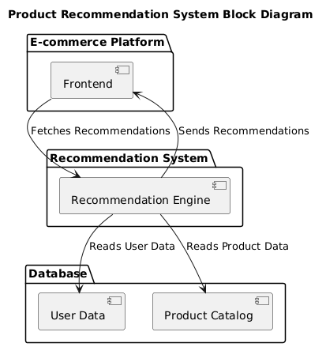

Figure : Block Diagram of PRS

###### Product functions

Product functions include the functional requirement of **Product Recommendation system.**

**Functional Requirements**

1. Generate Product Recommendations
2. View Product Details
3. Provide Feedback on Recommendations
4. Manage User Profile
5. Login and Logout
6. Search for Products
7. View Purchase History

|  |  |  |  |  |
| --- | --- | --- | --- | --- |
| **ID**: | FR_01 |  |  |  |
| **Name:** | Generate Product Recommendations |  |  |  |
| **Description** | **Input** | **Output** | **Requirements** | **Basic Work Flow** |
| |  | | --- | | The system should generate product recommendations based on user preferences, browsing history, and other relevant data. |  |  | | --- | |  | | |  | | --- | | User preferences, browsing history, purchase history |  |  | | --- | |  | | |  | | --- | | List of recommended products |  |  | | --- | |  | | User data must be collected and stored properly. Recommendation algorithm must be defined and tested.. | Collect user data (preferences, browsing history). Process data using recommendation algorithms. Display a list of recommended products. |

Table 1 Functional Requirement Generate Product Recommendations

|  |  |  |  |  |
| --- | --- | --- | --- | --- |
| **ID:** | FR_02 |  |  |  |
| **Name:** | View Product Details |  |  |  |
| **Description** | **Input** | **Output** | **Requirements** | **Basic Work Flow** |
| |  | | --- | | The system should allow the user to view detailed information about a recommended product. |  |  | | --- | |  | | |  | | --- | | Product ID or selection from recommendation list |  |  | | --- | |  | | |  | | --- | | Detailed information about the product (description, price, ratings, etc.) |  |  | | --- | |  | | Product data must be available and up-to-date in the system. | User selects a product. System fetches and displays detailed information about the selected product. |

Table : Functional Requirement View Product Details

|  |  |  |  |  |
| --- | --- | --- | --- | --- |
| **ID:** | FR_03 |  |  |  |
| **Name:** | |  | | --- | | Provide Feedback on Recommendations |  |  | | --- | |  | |  |  |  |
| **Description** | **Input** | **Output** | **Requirements** | **Basic Work Flow** |
| |  | | --- | | The system should allow users to provide feedback on the product recommendations they receive. |  |  | | --- | |  | | |  | | --- | | Rating (1-5 stars), comments |  |  | | --- | |  | | |  | | --- | | Confirmation of feedback submission |  |  | | --- | |  | | Feedback data must be saved and processed for future recommendations. | User selects a product. User provides a rating and feedback. System records feedback and updates user preferences. |

Table : Functional Requirement Provide Feedback on Recommendations

|  |  |  |  |  |
| --- | --- | --- | --- | --- |
| **ID:** | FR_04 |  |  |  |
| **Name:** | |  | | --- | | Manage User Profile |  |  | | --- | |  | |  |  |  |
| **Description** | **Input** | **Output** | **Requirements** | **Basic Work Flow** |
| |  | | --- | | The system should allow users to create, update, or delete their profiles. |  |  | | --- | |  | | |  | | --- | | Name, email, password, preferences |  |  | | --- | |  | | |  | | --- | | Updated user profile |  |  | | --- | |  | | Profile data must be secure and easily accessible for future sessions. | User inputs information or updates preferences. System updates the user profile in the database. |

Table : Functional Requirement Manage User Profile

|  |  |  |  |  |
| --- | --- | --- | --- | --- |
| **ID:** | FR_05 |  |  |  |
| **Name:** | |  | | --- | | Login and Logout | | |  | | --- | |  | |  |  |
| **Description** | **Input** | **Output** | **Requirements** | **Basic Work Flow** |
| |  | | --- | | The system should allow users to log in and log out of their accounts. |  |  | | --- | |  | | |  | | --- | | Username, Password |  |  | | --- | |  | | |  | | --- | | Login success or error message / Logout confirmation |  |  | | --- | |  | | Secure authentication mechanism. | User inputs credentials. System verifies credentials. System allows access if valid, logs out if requested. |

Table : Functional Requirement Login & Logout

|  |  |  |  |  |
| --- | --- | --- | --- | --- |
| **ID:** | FR_06 |  |  |  |
| **Name:** | |  | | --- | | Search for Products | |  |  |  |
| **Description** | **Input** | **Output** | **Requirements** | **Basic Work Flow** |
| |  | | --- | | The system should allow users to search for products within the system. |  |  | | --- | |  | | |  | | --- | | Search query (keywords, filters) |  |  | | --- | |  | | |  | | --- | | List of products matching search query |  |  | | --- | |  | | Product database must be well-indexed for search. | User enters a search query. System processes the search. Display results based on query and filters. |

Table : Functional Requirement Search for Products

|  |  |  |  |  |
| --- | --- | --- | --- | --- |
| **ID:** | FR_07 |  |  |  |
| **Name:** | |  | | --- | | View Purchase History |  |  | | --- | |  | |  |  |  |
| **Description** | **Input** | **Output** | **Requirements** | **Basic Work Flow** |
| |  | | --- | | The system should allow users to view their past purchases and interactions with products. |  |  | | --- | |  | | |  | | --- | | User ID |  |  | | --- | |  | | |  | | --- | | List of past purchases, with product details and dates |  |  | | --- | |  | | Data must be available and up-to-date for each user. | User requests purchase history. System retrieves and displays purchase history from the database. |

Table : Functional Requirement View Purchase History

###### User characteristics

**The Product Recommendation System** is designed for a diverse group of users, each with different levels of technical expertise and experience. Below are the key characteristics of the intended users:

1. **Educational Level:**
   * The intended users may have varying educational backgrounds, ranging from high school graduates to college-educated individuals.
   * The majority of users are likely to have at least a basic understanding of e-commerce and online shopping, which makes the system user-friendly without requiring advanced technical knowledge.
2. **Experience:**
   * **Novice Users:** These are users with limited experience using online shopping platforms and may need simple recommendations and clear instructions to navigate the system.
   * **Intermediate Users:** Users who are familiar with online shopping but may not be experienced in using advanced product recommendation systems. They would likely appreciate some personalized suggestions but may not engage deeply with all available features.
   * **Advanced Users:** These are tech-savvy users who are accustomed to using online product recommendation systems and are likely to interact with advanced features like detailed preferences or fine-tuned product suggestions.
3. **Technical Expertise:**
   * **Low Technical Expertise:** Users who have limited or no technical knowledge. These users should be able to easily understand and interact with the system without encountering any complexities in user interface or functionality.
   * **Moderate Technical Expertise:** Some users might have a general understanding of how recommendation systems work, and they may expect a higher level of customization and accuracy in the recommendations.
   * **High Technical Expertise:** Users with more advanced technical skills may use the system to better understand recommendation algorithms or expect highly accurate and personalized recommendations based on complex data analysis.
4. **Tech Savviness:**
   * Most users will have basic proficiency in using smartphones, tablets, or computers. Since the product recommendation system will be accessible via web and mobile interfaces, it is important to ensure it is intuitive and accessible for users with varying levels of experience with digital platforms.
5. **Language and Accessibility Needs:**
   * Users may come from different cultural and linguistic backgrounds, so the system should support multiple languages and offer accessibility features such as screen reader compatibility and simplified interfaces for those with disabilities.
6. **Behavior and Preferences:**
   * Users will have different shopping habits and preferences. Some may prefer to shop quickly with minimal interaction, while others may enjoy exploring more personalized suggestions. The system should be able to accommodate these diverse preferences and offer both quick recommendations and in-depth product exploration.

###### Constraints

The development and implementation of the **Product Recommendation System** are subject to several constraints that impact the design, functionality, and overall performance of the system. These include

* Regulatory policies
* Hardware limitations
* Interfaces to other applications
* Parallel operation
* Audit functions
* Control functions
* Higher-order language requirements;
* Signal handshake protocols
* Reliability requirements
* Criticality of the application
* Safety and security considerations

**Regulatory Policies:**

* The system must comply with data privacy regulations, including GDPR (General Data Protection Regulation) for users in the European Union, and other regional data protection laws for users in different geographical regions.
* The system should adhere to e-commerce regulations regarding consumer rights and product information transparency.

**Hardware Limitations:**

* The system should be able to run efficiently on standard web hosting platforms with average computational resources.
* The product recommendation algorithms should be optimized to run on typical consumer devices, such as smartphones, tablets, and desktop computers, without excessive strain on device resources.

**Interfaces to Other Applications:**

* The system should integrate seamlessly with e-commerce platforms (e.g., Shopify, WooCommerce) to fetch product data for recommendations.
* The system must support API integration with third-party payment gateways for processing transactions related to recommended products.

**Parallel Operation:**

* The recommendation system must support concurrent users without significant performance degradation, ensuring that multiple users can access recommendations and interact with the platform simultaneously.

**Audit Functions:**

* The system must include logging mechanisms to track user interactions, feedback, and system performance for auditing and troubleshooting purposes.
* User feedback on recommendations must be stored for future analysis and improvement of the recommendation algorithm.

**Control Functions:**

* The system should have administrative controls to manage user accounts, including the ability to ban or suspend accounts if fraudulent activity is detected.
* Administrators should be able to update the recommendation algorithms based on new data and trends.

**Higher-Order Language Requirements:**

* The system must be developed using widely accepted higher-order languages like Python (for data processing and recommendation algorithms), JavaScript (for web interfaces), and SQL (for database queries).
* The use of machine learning libraries like TensorFlow or scikit-learn may be required for the recommendation engine.

**Signal Handshake Protocols:**

* The system must ensure secure communication between the client (user) and server, using SSL/TLS encryption to protect data during transmission.
* APIs for integration with third-party services (e.g., product data feeds or payment gateways) should comply with standard HTTP/HTTPS protocols and secure authorization methods.

**Reliability Requirements:**

* The system must ensure 99% uptime, with minimal downtime for maintenance or updates.
* Failover mechanisms should be in place to handle unexpected server failures, ensuring that the recommendation service remains available to users.

**Criticality of the Application:**

* As a customer-facing e-commerce application, the product recommendation system is considered critical for user engagement and revenue generation. Any significant downtime or failures could directly affect user experience and sales.

**Safety and Security Considerations:**

* User data, including personal and payment information, must be securely stored and encrypted.
* The system should include measures to prevent common web security vulnerabilities, such as SQL injection, cross-site scripting (XSS), and cross-site request forgery (CSRF).
* Regular security audits should be conducted to ensure that the system is protected against emerging threats.

###### Assumptions and dependencies

* **Assumptions**

**1. Availability of Data**:

Sufficient and high-quality data on user preferences, product details, and purchase history will be available for training and testing the recommendation model.

**2. User Interaction**:

Users will provide feedback (e.g., ratings, likes, or dislikes) on recommended products, which will be used to improve the recommendation algorithm.

**3. Technical Infrastructure**:

Users will have access to devices (smartphones, tablets, or computers) with internet connectivity to interact with the system.

**4. Algorithm Performance**:

The recommendation algorithms (e.g., collaborative filtering, content-based filtering) will perform effectively with the available data and provide accurate recommendations.

**5. User Adoption**:

Users will be willing to adopt and regularly use the system for product discovery and decision-making.

**6. Product Catalog**:

The product catalog will be regularly updated with accurate and detailed information (e.g., descriptions, categories, prices).

**7. Scalability**:

The system will scale effectively as the number of users and products grows over time.

* **Dependencies**

**1. Data Sources:**

The system depends on external data sources (e.g., product databases, user interaction logs) for training and updating the recommendation model.

**2. Third-Party APIs:**

Integration with third-party APIs (e.g., payment gateways, product inventory systems) may be required for seamless functionality.

**3. Machine Learning Libraries:**

The system relies on machine learning libraries (e.g., TensorFlow, Scikit-learn) for implementing and optimizing recommendation algorithms.

**4. Cloud Infrastructure:**

The system may depend on cloud services (e.g., AWS, Google Cloud) for storage, computation, and deployment.

**5. User Feedback Mechanism:**

The system depends on user feedback to continuously improve the recommendation accuracy and relevance.

**6. Maintenance and Updates:**

Ongoing maintenance and updates to the product catalog, algorithms, and user interface are necessary for the system to remain effective.

###### Apportioning of requirements

The following requirements may be delayed or implemented in future versions of the **Product Recommendation System**, depending on project timelines, resources, and prioritization:

**1. Advanced Personalization Features:**

The inclusion of advanced personalization features, such as sentiment analysis or deep learning models to predict user preferences, may be delayed to a later version due to the complexity of implementation and resource constraints.

**2. Integration with Additional E-commerce Platforms:**

Initially, the system will support integration with major e-commerce platforms like Shopify and WooCommerce. However, integration with additional platforms (e.g., Magento, BigCommerce) may be postponed until future versions of the system.

**3. Multi-language Support:**

The system may initially support only one language (e.g., English), with multi-language support (for different regions and localizations) being deferred to a future release.

**4. Advanced Search Filters:**

While the system will allow basic product search, advanced search filters (e.g., search by attributes like color, size, or custom user preferences) may be delayed to a future version.

**5. Real-time Recommendations:**

Real-time product recommendations based on user activity and trends may be introduced in future versions, as the initial version will rely on batch processing or static data for generating recommendations.

**6. User Feedback Analytics:**

Although user feedback will be collected, advanced analytics on feedback data (such as sentiment analysis and feedback-driven algorithm tuning) will be deferred to future versions of the system.

**7. Mobile App Support:**

Initially, the system will focus on a web-based interface. Support for a dedicated mobile app for product recommendations may be postponed for future development.

These requirements have been identified for potential apportionment to future releases of the **Product Recommendation System**, allowing for focused development in the initial phase while maintaining flexibility for future enhancements.

##### Specific requirements

###### Functional Requirement

The functional requirements describe the core functions and modules that the Product Recommendation System must support.

**1. User Management**

**User Registration and Login**:

* + Allow users to create accounts and log in securely.

**User Profile Management**:

* + Enable users to update their profiles with personal information, preferences, and interests.

**2. Product Catalog**

**Product Information Display**:

* + Display detailed product information, including name, category, price, description, and images.

**Product Search and Filtering**:

* + Allow users to search for products and apply filters (e.g., category, price range, ratings).

**3. Recommendation Engine**

**Collaborative Filtering**:

* + Generate recommendations based on user behavior and preferences (e.g., purchase history, ratings).

**Content-Based Filtering**:

* + Provide recommendations based on product attributes and user preferences.

**Hybrid Recommendations**:

* + Combine collaborative and content-based filtering for more accurate recommendations (future version).

**4. User Feedback**

**Rating and Reviews**:

* + Allow users to rate products and write reviews.

**Like/Dislike Feedback**:

* + Enable users to provide quick feedback (like/dislike) on recommended products.

**5. Personalization**

**Personalized Recommendations**:

* + Display product recommendations tailored to individual user preferences and behavior.

**Dynamic Updates**:

* + Update recommendations in real-time based on user interactions (e.g., clicks, purchases).

**6. Integration Module**

**Third-Party API Integration**:

* + Integrate with external systems (e.g., payment gateways, inventory management) for seamless functionality.

**Social Media Integration**:

* + Allow users to share products or recommendations on social media platforms (future version).

###### Non-functional Requirements

The non-functional requirements describe the qualities the system must exhibit in order to ensure a satisfactory user experience and performance.

**1. Usability:**

The system should have an intuitive and user-friendly interface to ensure ease of use for users with varying levels of technical expertise.

The system should include help and support documentation for users unfamiliar with e-commerce platforms or recommendation systems.

**2. Reliability:**

The system must be reliable and handle user requests without failures. It should have a 99% uptime guarantee, with minimal downtime for maintenance or updates.

The system should include error-handling mechanisms to ensure that issues such as missing product data or network errors do not disrupt the user experience.

**3. Performance:**

The system should be able to generate recommendations within a reasonable time (e.g., 2-5 seconds) even with large amounts of user data.

The system must be optimized for handling concurrent user requests without significant performance degradation.

**4. Design Constraints:**

The system must be developed using widely accepted and supported technologies (e.g., Python for recommendation algorithms, JavaScript for the user interface).

The user interface must be responsive, ensuring compatibility with both desktop and mobile devices.

The system must comply with security standards such as SSL/TLS encryption for secure data transmission.

**5. Portability:**

The system should be portable and able to run on various platforms, including different web browsers (Chrome, Firefox, Edge, Safari) and mobile devices (iOS, Android).

The system should support deployment on cloud services like AWS or Azure, allowing easy scalability and flexibility.

**6. Maintainability:**

The system should be modular and structured in a way that allows for easy maintenance and future updates.

The codebase should follow best practices for readability and documentation, ensuring that future developers can easily modify or extend the system.

**7. License Agreement:**

The system will use open-source libraries (e.g., TensorFlow, scikit-learn) under their respective licenses, and any third-party software will be subject to the applicable terms and conditions.

The product itself may be subject to licensing terms, depending on the chosen deployment and distribution model (e.g., subscription, freemium, etc.).

# Chapter 3: Use Case Analysis

The following use case diagrams represent key functionalities of the **Product Recommendation System:**

* Use Case Diagram for User Registration and Login
* Use Case Diagram for Generating Product Recommendations
* Use Case Diagram for Viewing Product Details
* Use Case Diagram for Providing Feedback on Recommendations
* Use Case Diagram for Searching for Products
* Use Case Diagram for Viewing Purchase History
* Aggregated Use Case Diagram

## 3.1. Use Case Diagram for User Registration and Login

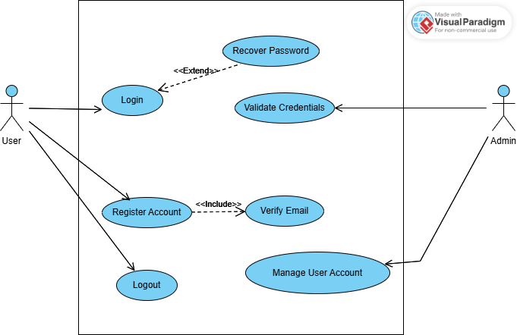

Figure : Use Case Diagram for User Registration and Login

### 3.1.1 User Registration and Login

|  |  |  |
| --- | --- | --- |
| **Use Case ID** | UC_01 | |
| **Use Case Name** | User Registration and Login | |
| **Description** | |  | | --- | | Allows users to create an account and log in to access recommendations. |  |  | | --- | |  | | |
| **Primary Actor** | User | |
| **Secondary Actor** | Admin | |
| **Pre-Condition** | |  | | --- | | The user must have a valid email and password. |  |  | | --- | |  | | |
| **Post-Condition** | |  | | --- | | The user account is created, and the user is logged in successfully. |  |  | | --- | |  | | |
| **Basic Flow** | **Actor Action** | **System Action** |
|  | 1. User enters registration details (email, password, preferences).  System validates details and creates an account.  3. User logs in using credentials | 2. System validates details and creates an account.  4. System grants access and redirects to the homepage. |
| **Alternate Flow** | If credentials are incorrect, the system displays an error message and prompts for retry. | |

Table 8 Use Case User Registration and login

## 3.2. Use Case Diagram for Generating Product Recommendations

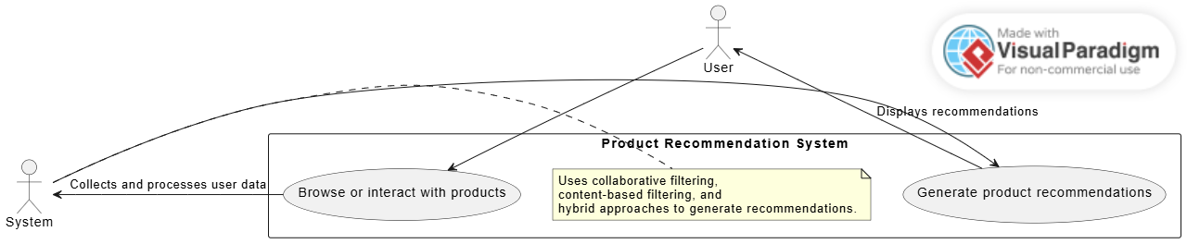

Figure : Use Case Diagram Generating Product Recommendation

### 3.2.1 Generate Product Recommendations

|  |  |  |
| --- | --- | --- |
| **Use Case ID** | UC_02 | |
| **Use Case Name** | Generate Product Recommendations | |
| **Description** | |  |  |  | | --- | --- | --- | | |  | | --- | | The system provides personalized product recommendations based on user preferences and history. |  |  | | --- | |  | |  |  | | --- | |  | | |
| **Primary Actor** | User | |
| **Secondary Actor** | System | |
| **Pre-Condition** | |  | | --- | | The user must be logged in with sufficient interaction history. |  |  | | --- | |  | | |
| **Post-Condition** | |  | | --- | | The system generates and displays personalized recommendations. |  |  | | --- | |  | | |
| **Basic Flow** | **Actor Action** | **System Action** |
|  | 1. User browses or interacts with products.  4. Recommendations are displayed to the user. | 2. System collects and processes user data.  3. System generates product recommendations based on filtering algorithms. |
| **Alternate Flow** | If insufficient data is available, the system suggests popular or trending products. | |

Table : Use Case Generating Product Recommendation

## 3.3 Use Case Diagram for Viewing Product Details

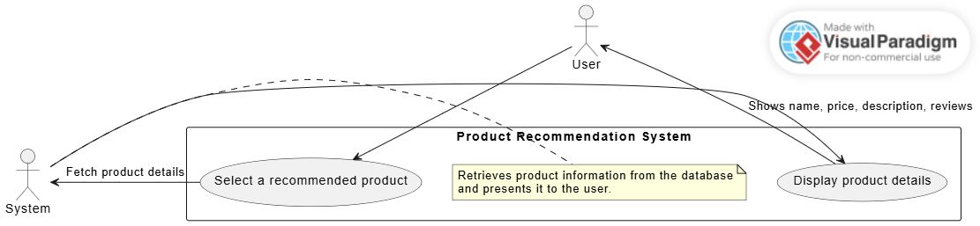

Figure : Use Case Diagram View Product Details

### 3.3.1 Viewing Product Details

|  |  |  |
| --- | --- | --- |
| **Use Case ID** | UC_03 | |
| **Use Case Name** | Viewing Product Details | |
| **Description** | |  |  |  | | --- | --- | --- | | |  | | --- | | Allows users to view detailed information about a recommended product. |  |  | | --- | |  | |  |  | | --- | |  | | |
| **Primary Actor** | User | |
| **Secondary Actor** | System | |
| **Pre-Condition** | |  | | --- | | The user selects a product from the recommendation list. |  |  | | --- | |  | | |
| **Post-Condition** | |  | | --- | | The product details are displayed to the user. |  |  | | --- | |  | | |
| **Basic Flow** | **Actor Action** | **System Action** |
|  | 1. User clicks on a recommended product. | 2. System fetches and displays product details (name, price, description, reviews, etc.). |
| **Alternate Flow** | If product data is unavailable, the system displays an error message. | |

Table : Use Case Viewing Product Detail

## 3.4. Use Case Diagram for Providing Feedback on Recommendations

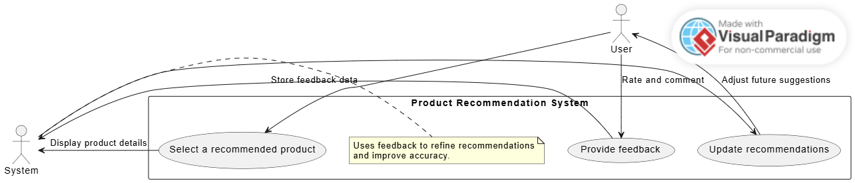

Figure : Use Case Diagram Providing Feedback

### 3.4.1 Providing Feedback on Recommendations

|  |  |  |
| --- | --- | --- |
| **Use Case ID** | UC_04 | |
| **Use Case Name** | Providing Feedback on Recommendations | |
| **Description** | |  |  |  | | --- | --- | --- | | |  | | --- | | Allows users to provide feedback (ratings/comments) on product recommendations. |  |  | | --- | |  | |  |  | | --- | |  | | |
| **Primary Actor** | User | |
| **Secondary Actor** | System | |
| **Pre-Condition** | |  | | --- | | The user has received recommendations. |  |  | | --- | |  | | |
| **Post-Condition** | |  | | --- | | Feedback is recorded and used to refine future recommendations. |  |  | | --- | |  | | |
| **Basic Flow** | **Actor Action** | **System Action** |
|  | 1. User selects a recommended product.  2. User provides a rating and optional comment. | 3. System records the feedback. |
| **Alternate Flow** | If feedback submission fails, the system prompts the user to retry. | |

Table : Provide Feedback on Recommendation

## 3.5. Use Case Diagram for Searching for Products

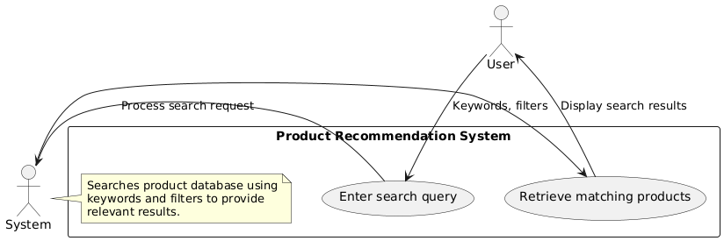

Figure : Use Case Diagram for Search Products

### 3.5.1. Searching for Products

|  |  |  |
| --- | --- | --- |
| **Use Case ID** | UC_05 | |
| **Use Case Name** | Searching for Products | |
| **Description** | |  |  |  | | --- | --- | --- | | |  | | --- | | Allows users to search for products within the system. |  |  | | --- | |  | |  |  | | --- | |  | | |
| **Primary Actor** | User | |
| **Secondary Actor** | System | |
| **Pre-Condition** | |  | | --- | | The user enters a search query. |  |  | | --- | |  | | |
| **Post-Condition** | |  | | --- | | The system displays relevant search results. |  |  | | --- | |  | | |
| **Basic Flow** | **Actor Action** | **System Action** |
|  | 1. User enters a search query (keywords, filters). | 2. System retrieves and displays matching products. |
| **Alternate Flow** | If no products match, the system suggests alternative keywords. | |

Table : Searching for Products

## 3.6. Use Case Diagram for Viewing Purchase History

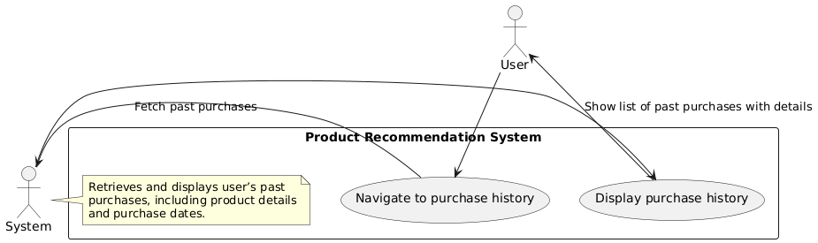

Figure : Use Case Diagram View Purchase History

### 3.6.1. Viewing Purchase History

|  |  |  |
| --- | --- | --- |
| **Use Case ID** | UC_06 | |
| **Use Case Name** | View Purchase History | |
| **Description** | |  |  |  | | --- | --- | --- | | |  | | --- | | Allows users to view their past purchases. |  |  | | --- | |  | |  |  | | --- | |  | | |
| **Primary Actor** | User | |
| **Secondary Actor** | System | |
| **Pre-Condition** | |  | | --- | | The user must have previous purchase records. |  |  | | --- | |  | | |
| **Post-Condition** | |  | | --- | | The system displays the user’s purchase history. |  |  | | --- | |  | | |
| **Basic Flow** | **Actor Action** | **System Action** |
|  | 1. User navigates to the purchase history section. | 2. System fetches and displays past purchases with details. |
| **Alternate Flow** | If no purchase history is found, the system notifies the user. | |

Table : Viewing Purchase History Use Case

## 3.7. Aggregated Use Case Diagram

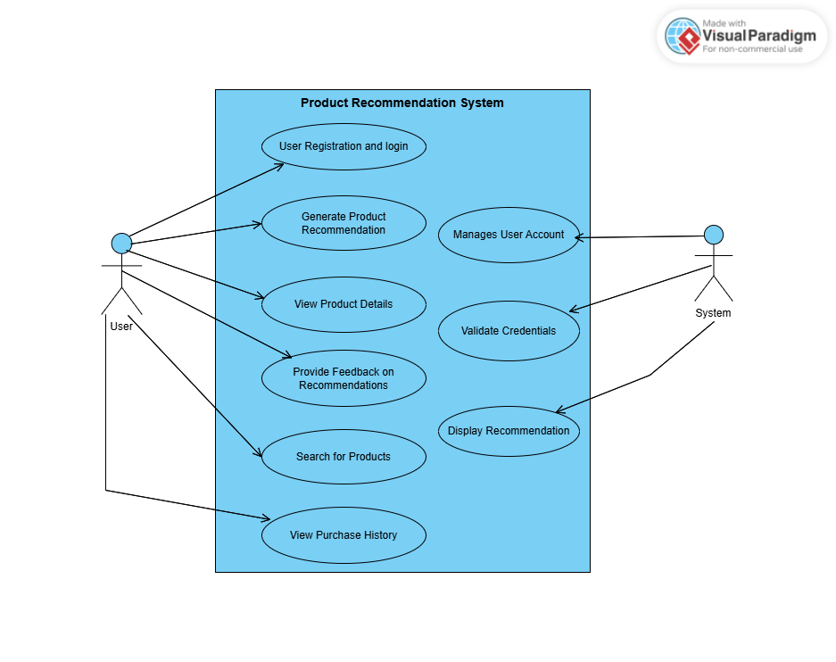

Figure : Aggregated Use Case Diagram of PRS

# Chapter 4: Design

This chapter focuses on the design analysis of **Product Recommendation System (PRS)** and includes various design diagrams.

1. Architecture Diagram
2. ERD with data dictionary
3. Data Flow diagram
4. Class Diagram
5. Activity Diagram
6. Sequence Diagram
7. Collaboration Diagram
8. State Transition Diagram
9. Component Diagram
10. Deployment Diagram

#### Architecture Diagram

A graphical representation of the system’s **concepts, principles, elements, and components**.

It shows the interaction between different system components.

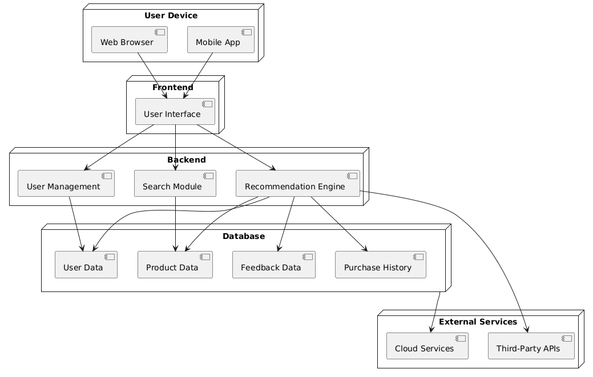

Figure 9 Architecture Diagram of PRS

#### ERD with data dictionary

EntityRelationshipDiagram with complete relations with dependencies of your project

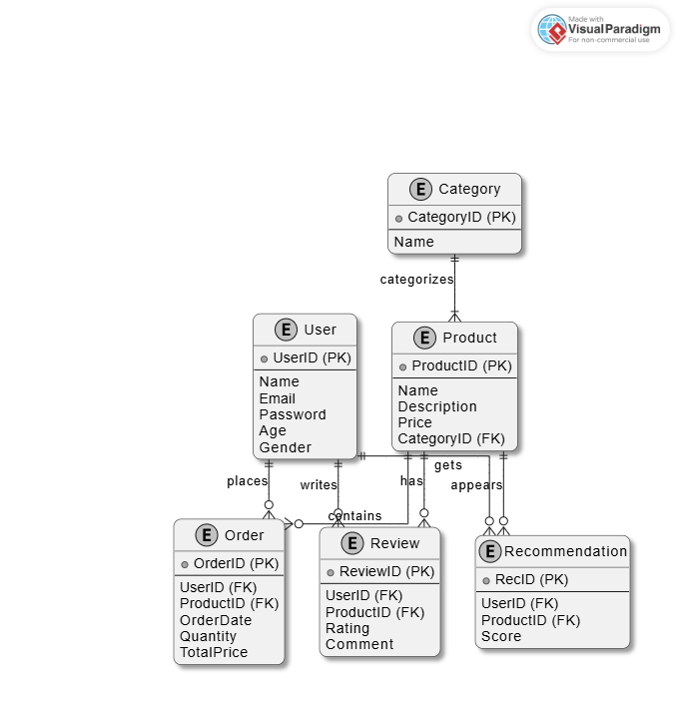

Figure 10 ERD of PRS

#### Class Diagram

Describe the structure of a project by showing the systems classes, their attributes, operations (or methods), and the relationships among objects.

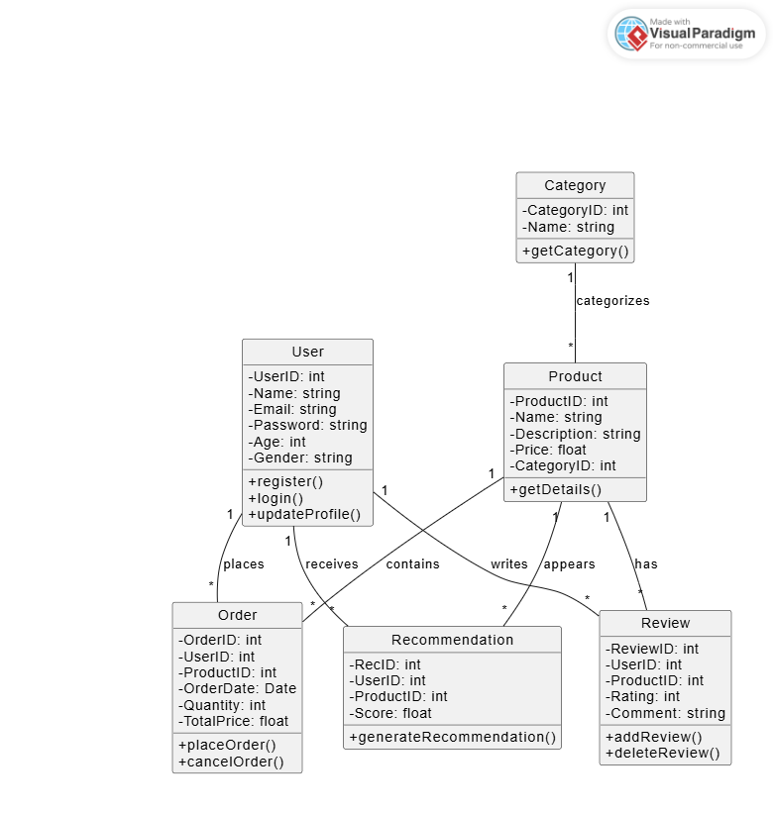

Figure 11 Class Diagram

#### Activity Diagram

This diagram includes all the activity diagrams of the functional requirements of your project along with the aggregated activity diagram.

The Activities involved in Product Recommendation System include :

1. User Registration and Login
2. Generating Product Recommendations
3. Viewing Product Details
4. Providing Feedback on Recommendations
5. Searching for Products
6. Viewing Purchase History

##### User Registration and Login

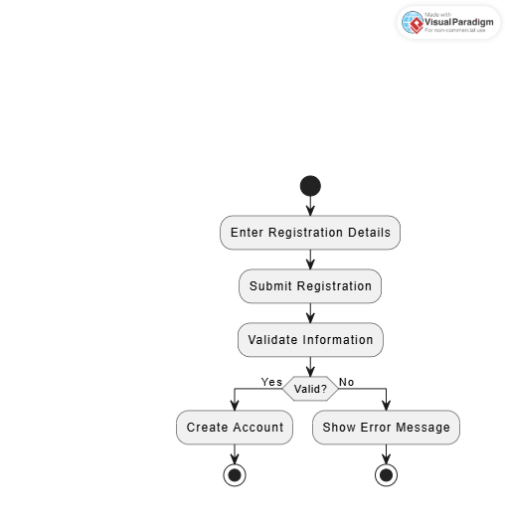

Figure : User Registration and Login

##### Generating Product Recommendations

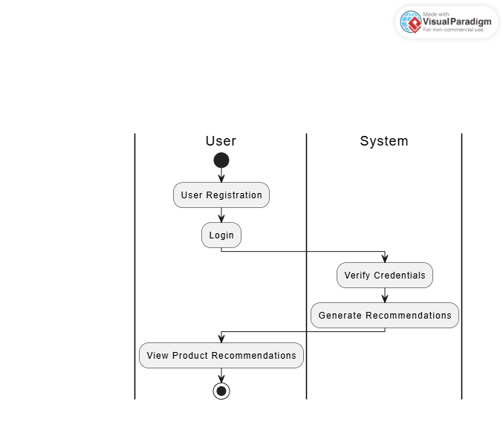

Figure : Generating Product Recommendations

##### Viewing Product Details

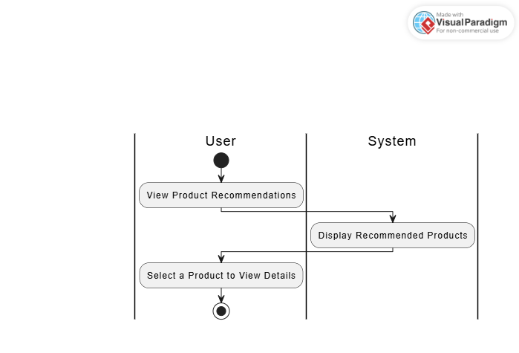

Figure : View Product Details Activity

##### Provide Feedback on Rcommendations

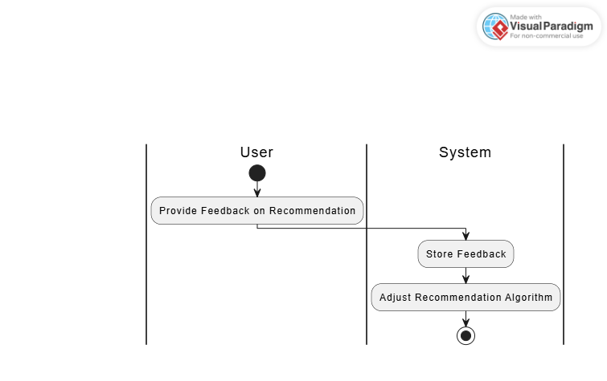

Figure : Provide Feedback on Recommendation

##### Search for Products

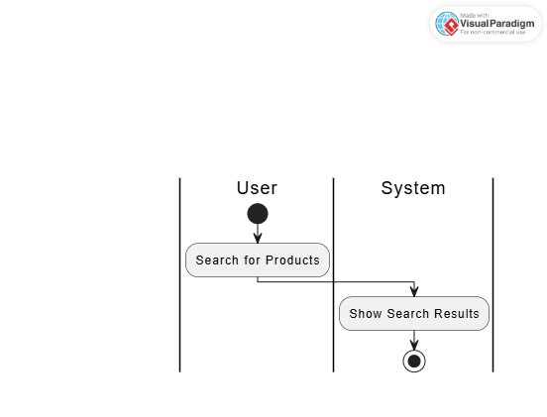

Figure : Search for Products Activity

##### View Purchase History

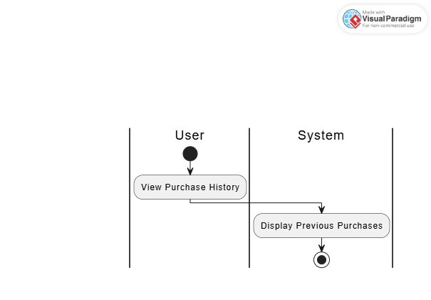

Figure : View Purchase History

##### 4.4.7 Aggregated Activity Diagram of PRS

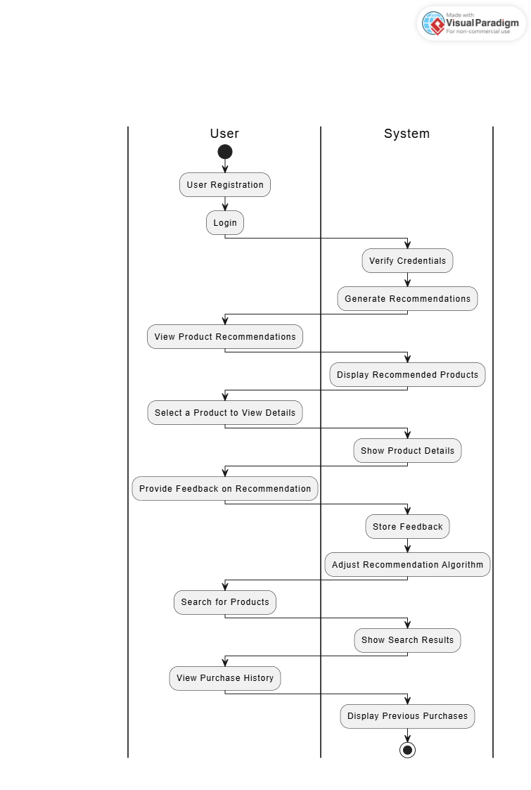

Figure : Activity Diagram of PRS

#### Sequence Diagram

This diagram includes all the Sequence diagrams of the functional requirements of your project along with the aggregated Sequence diagram .

The Sequence Diagrams involved in Product Recommendation System include :

1. User Registration and Login
2. Generating Product Recommendations
3. Viewing Product Details
4. Providing Feedback on Recommendations
5. Searching for Products
6. Viewing Purchase History

##### User Registration and Login

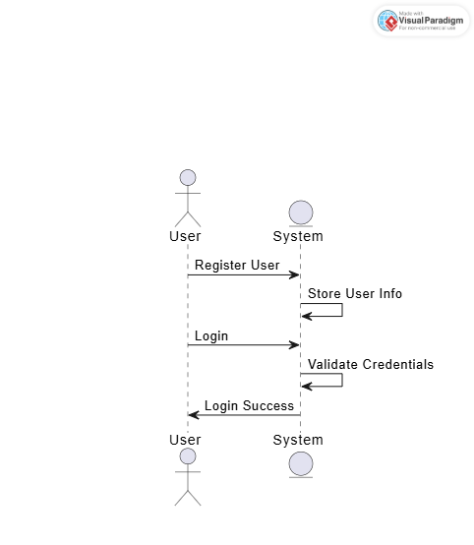

Figure : Sequence diagram for User Registration and login

##### Generating Product Recommendations

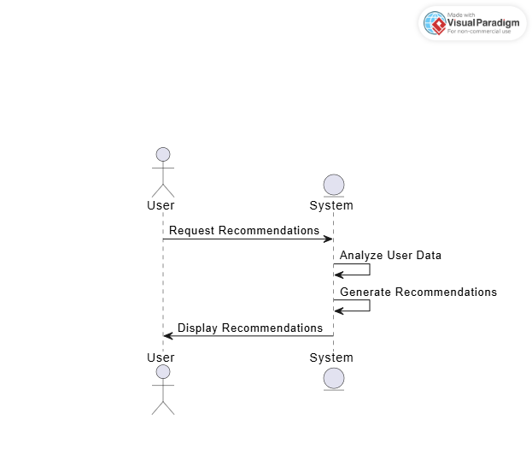

Figure : Sequence diagram for Generating Product Recommendations

##### Viewing Product Details

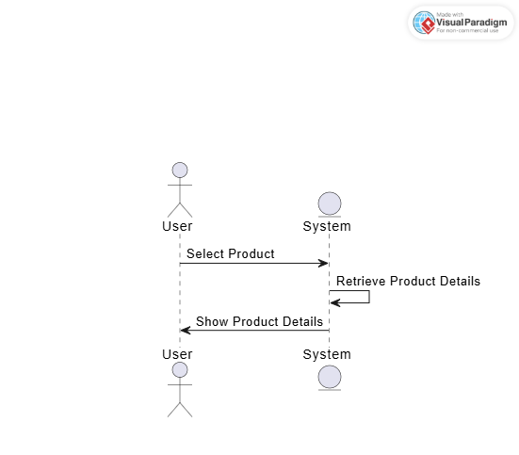

Figure : Sequence diagram for View Product Details

##### Providing Feedback on Recommendations

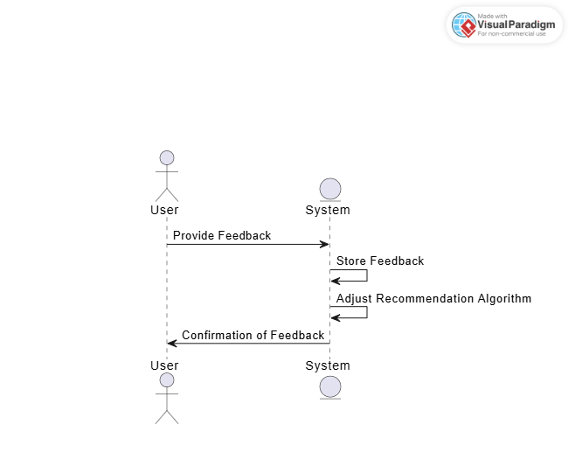

Figure : Sequence diagram for Provide Feedback on Recommendations

##### Searching for Products

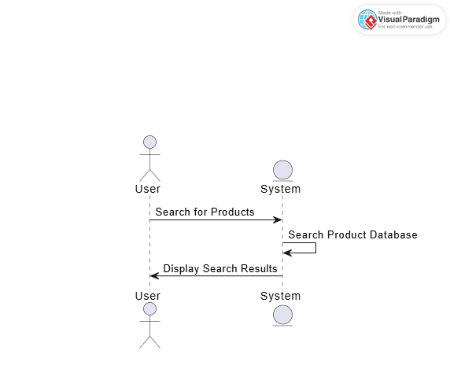

Figure : Sequence diagram for Search for products

##### Viewing Purchase History

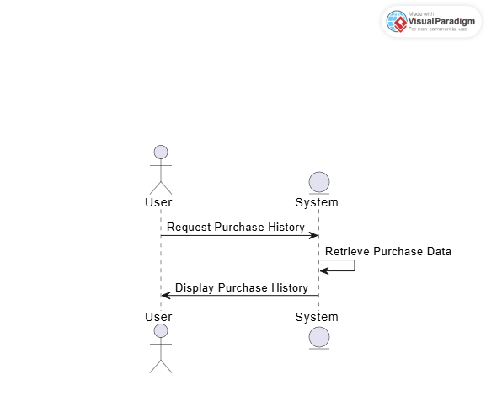

Figure : Sequence diagram for View Purchase history

##### Aggregated Diagram

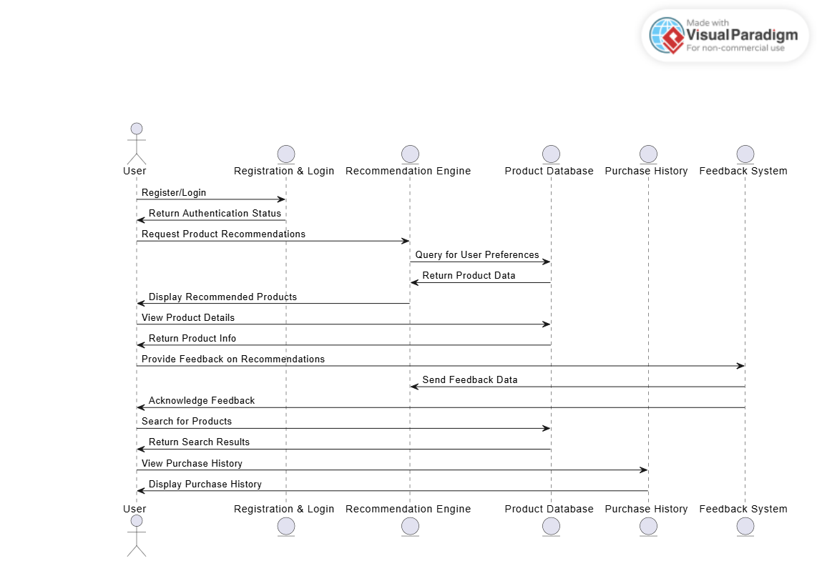

Figure : Sequence Diagram of PRS

#### Collaboration Diagram

A Collaboration Diagram (also known as Communication Diagram in UML) is a type of interaction diagram that shows the interactions between objects or components in a system. It focuses on the structural organization of the system by illustrating how objects or classes collaborate with each other to complete a task or fulfill a use case.

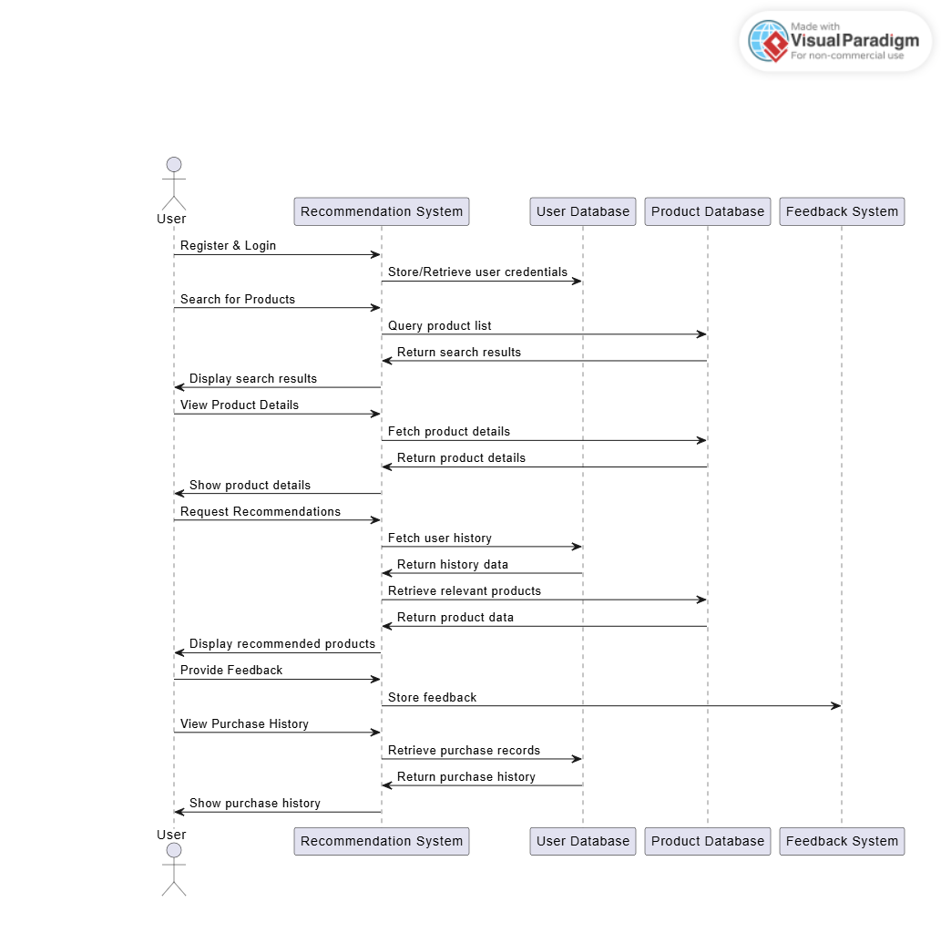

Figure 26 Collaboration Diagram of PRS

#### Data Flow Diagram

A Data Flow Diagram (DFD) is a visual representation of the flow of data within a system. It is used to show how information moves between processes, data stores, and external entities, as well as how it is transformed during its journey through the system.

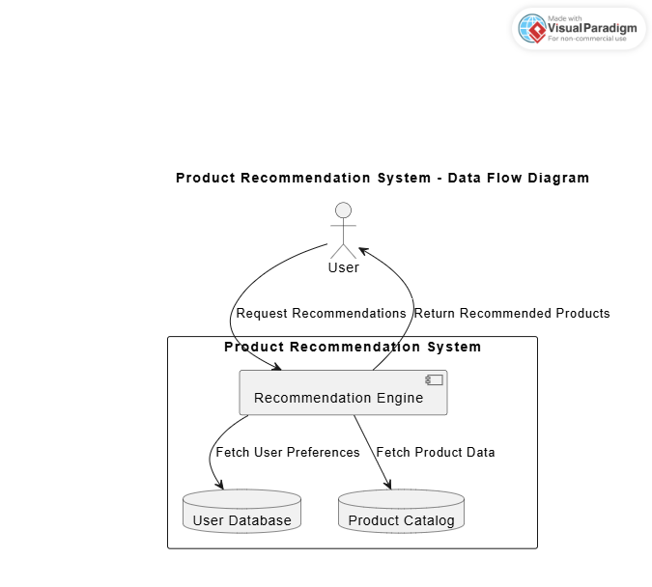

Figure : DFD of PRS

#### Component Diagram

A Component Diagram is a type of UML (Unified Modeling Language) diagram used to model the physical and logical components of a system. It focuses on the components (or modules) that make up a software system, their dependencies, and their relationships. It is mainly used to show the system architecture at a high level, illustrating how the system is broken down into smaller, reusable components that interact with each other.

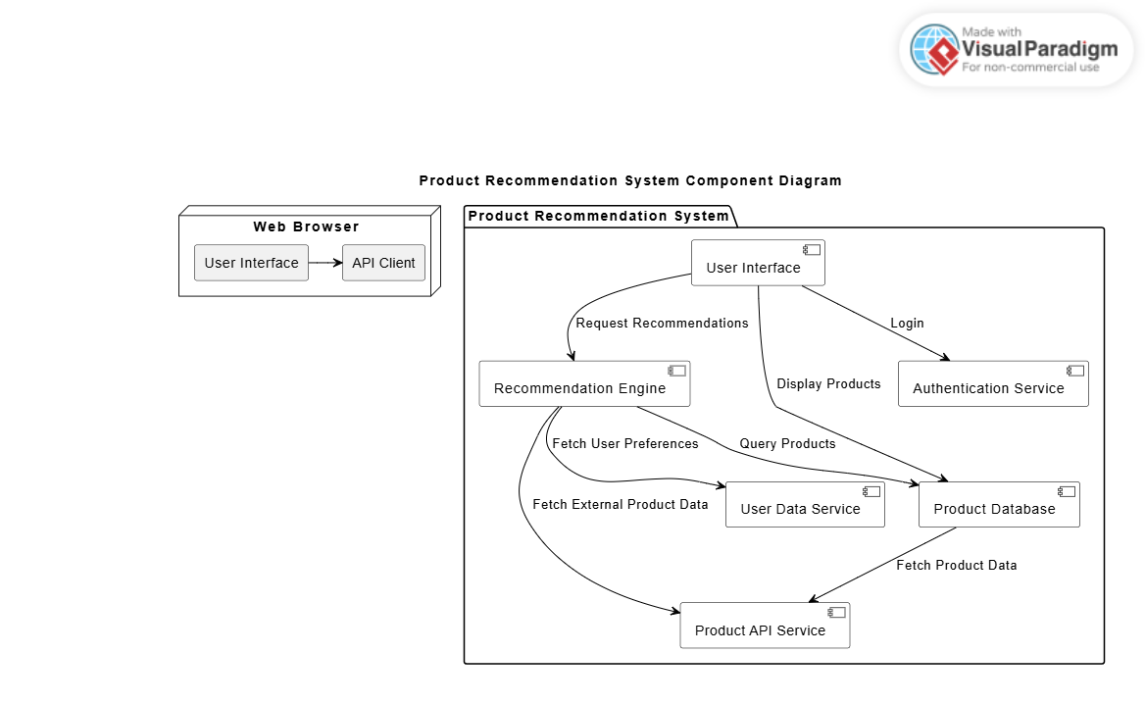

Figure : Component Diagram of PRS

#### State Transition Diagram

A State Transition Diagram (or State Machine Diagram) is a type of UML diagram used to model the states that an object or system can be in and how it transitions between these states based on events or conditions. It is especially useful in situations where an object or system undergoes a series of state changes in response to specific events.

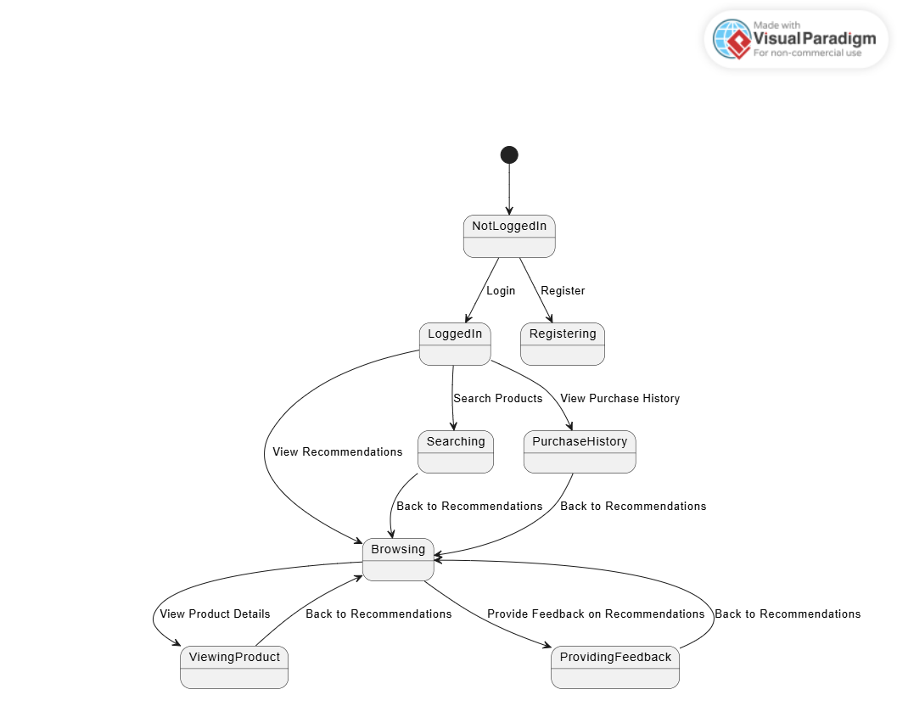

Figure : ST diagram of PRS

#### 4.10 Deployment Diagram

Deployment diagram represents the deployment view of a system. It is related to the component diagram. Because the components are deployed using the deployment diagrams. A deployment diagram consists of nodes. Nodes are nothing but physical hardware’s used to deploy the application.

Deployment diagrams are useful for system engineers. An efficient deployment diagram is very important because it controls the following parameters

1. Performance
2. Scalability
3. Maintainability
4. Portability

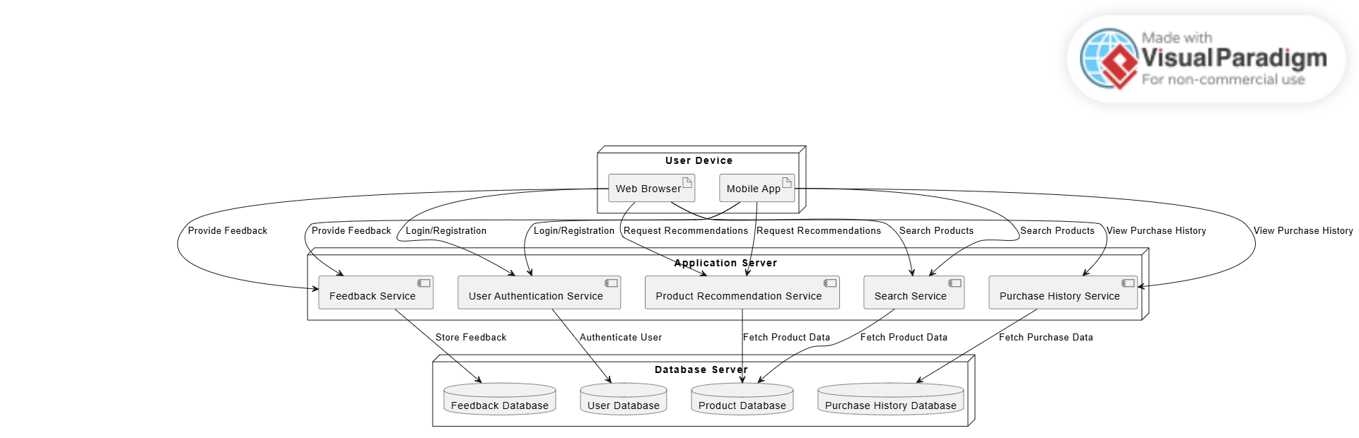

Figure : Deployment Diagram od PRS

# References

# 

[1] Abe, M., Nakamura, S., Shikano, K., & Kuwabara, H. (1990). Voice conversion through vector quantization. *Journal of the Acoustical Society of Japan*, E-11, 71-76.

[2] Hermansky, H. (1990). Perceptual linear predictive (PLP) analysis for speech. *Journal of the Acoustical Society of America*, 1738-1752.

[3] Leveson, N. G. (1995). *Safeware System Safety and Computers: A Guide to Preventing Accidents and Losses Caused by Technology*. Addison-Wesley Publishing Company, Inc.

[4] Brooks, R. R., & Iyengar, S. S. (1998). *Multi-Sensor Fusion Fundamentals and Applications with Software*. The Prentice-Hall Inc.

[5] Ricci, F., Rokach, L., & Shapira, B. (2011). *Introduction to Recommender Systems Handbook*. Springer.

[6] Koren, Y., Bell, R., & Volinsky, C. (2009). Matrix factorization techniques for recommender systems. *Computer*, 42(8), 30-37.

[7] <https://sites.google.com/uol.edu.pk/final-year-project/documentation-template>

[8] https://www.drawio.com/

[9] https://www.bing.com/search?EID=MBSC&form=BGGCMF&pc=U746&DPC=BG02&q= plant+uml&PC=U316&FORM=CHROMN

[10] https://www.bing.com/search?q=visual+paradigm+online&qs=HS&pq=visual&sc=12-6&cvid=891777EFEE2E432095C6A11E8C9514BD&FORM=QBRE&sp=1&ghc=1&lq=0

[11].https://www.bing.com/search?EID=MBSC&form=BGGCMF&pc=U746&DPC=BG02&q=chatgpt&PC=U316&FORM=CHROMN

[12].https://www.researchgate.net/publication/353757917_Product_Recommendation_System_A_Systematic_Literature_Review

[13].

# 

# Appendix

**Appendix A: Dataset Description** This section provides an overview of the dataset used for the recommendation system, including:

* Number of users and products
* Attributes used for recommendation (e.g., user ratings, product categories, timestamps)
* Data preprocessing steps

**Appendix B: Algorithm Implementation Details** A step-by-step breakdown of the recommendation algorithm:

* Collaborative Filtering (User-based and Item-based)
* Content-Based Filtering
* Hybrid Model Approach
* Model Evaluation Metrics (Precision, Recall, F1-score, RMSE)

**Appendix C: System Deployment Guide** This section details the deployment process:

* Server Requirements
* Database Setup
* API Configuration
* Frontend and Backend Integration

**Appendix D: User Guide** Instructions for end-users on how to navigate and use the system:

* How to register and log in
* Searching and filtering products
* Viewing recommendations
* Providing feedback on recommendations

**Appendix E: Test Cases and Results** Includes:

* Functional test cases for key features
* Performance testing results
* Security testing reports